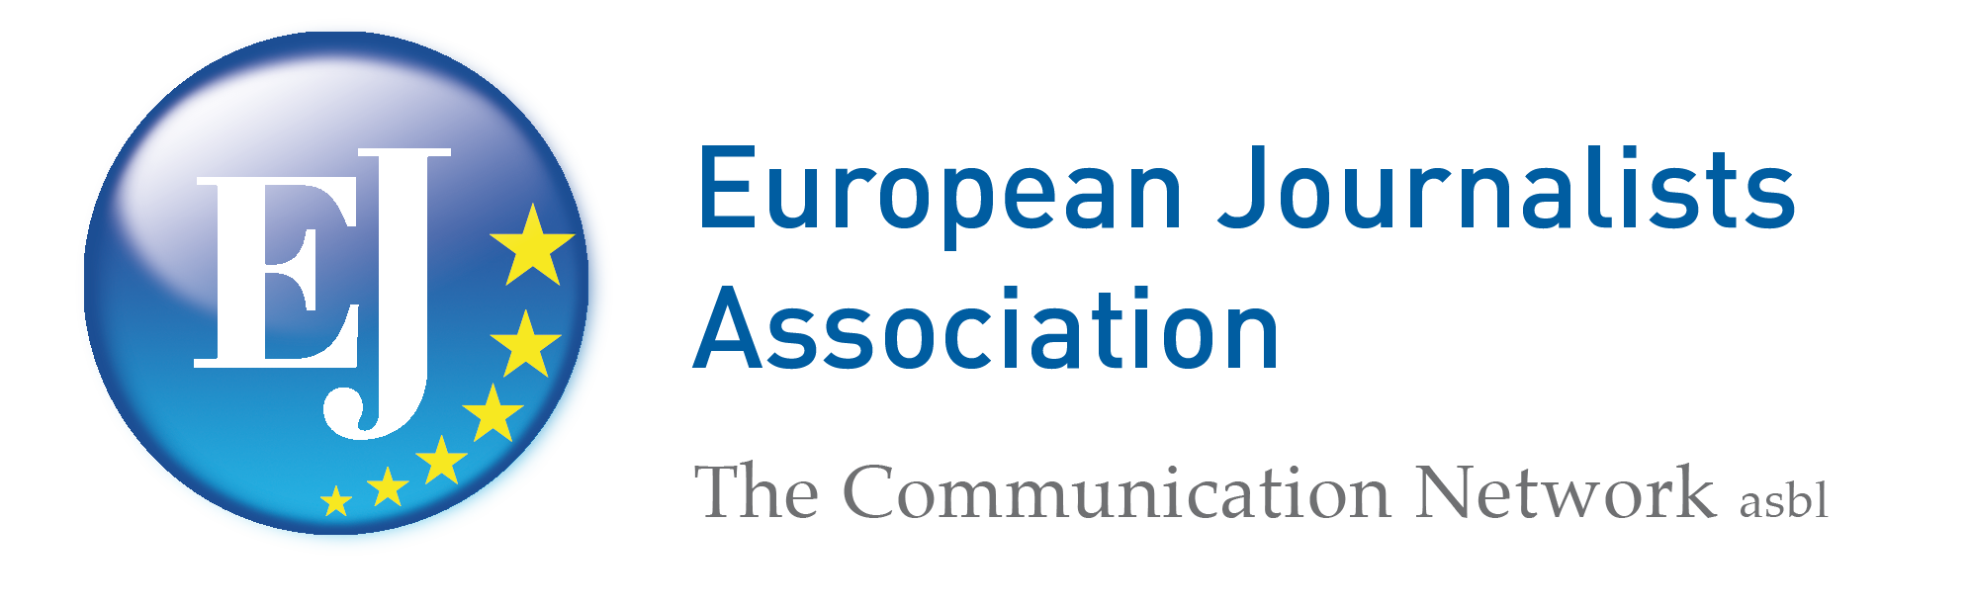
50th Jubilee EJ Congress in Bulgaria

The “Pirin Golf & Country Club” of Razlog, in Bulgaria, surrounded by the majestic Pirin and Rila mountains hosted on September 20-23, 2012 the 50th Jubilee congress of the European Journalists Association – the Communication Network.
About 100 journalists from EU and non-EU countries and prominent speakers took part in the event and the EJ proudly celebrated 50 years of its foundation. They recalled the initial congress which took place in the Italian city of San Remo in 1962, where a group about 70 journalists coming from the six member states of the European Community at that time gathered to undertake a common effort to contribute to the promotion of the European project by informing and involving citizens in the process of the European unification.

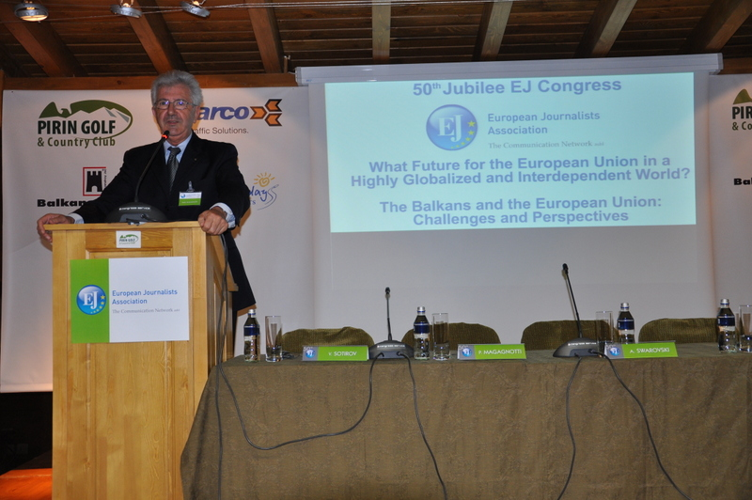

EJ President Paolo Magagnotti opens the Congress

The congress was honored by the presence of three special guests: Maria Romana De Gasperi, daughter of Europe’s founding father Alcide De Gasperi; Sven-Georg Adenauer, grandson of Europe’s founding father Konrad Adenauer, and Alexander Swarovski of Swarovski Crystal and vice-president of SWARCO - the worldwide leader company in traffic solutions, EJ official sponsor.
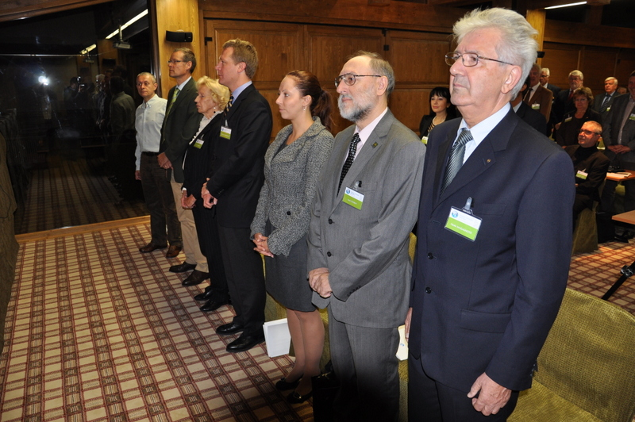

,

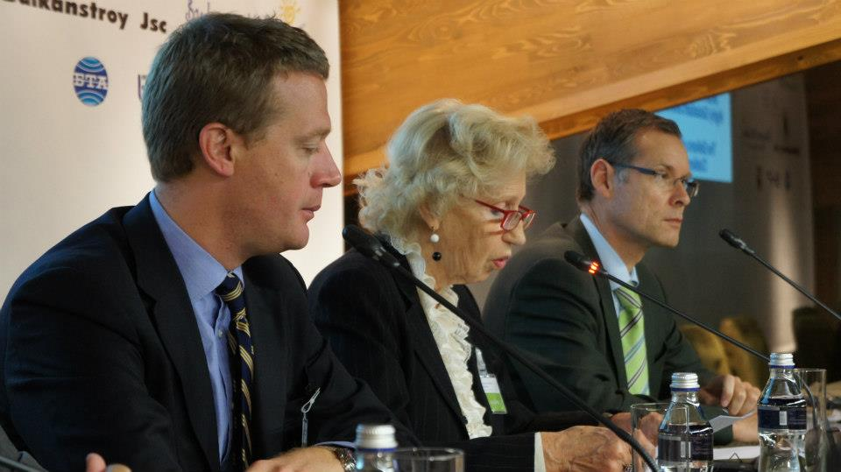

The guests of honor. From left: Alexander Swarovski,
Maria Romana
De Gasperi,
Sven-Georg Adenauer.

The European institutions congratulated the participants with two video messages from the President of the European Parliament Martin Schulz

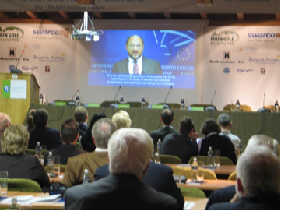
Video message by the EP President Martin Schulz

and the vice-president of the European Commission Viviane Reding. Messages were also received from the Prime Minister of Bulgaria Boyko Borisov and from the head of the Representation of the European Commission in Bulgaria Zinaida Zlatanova.

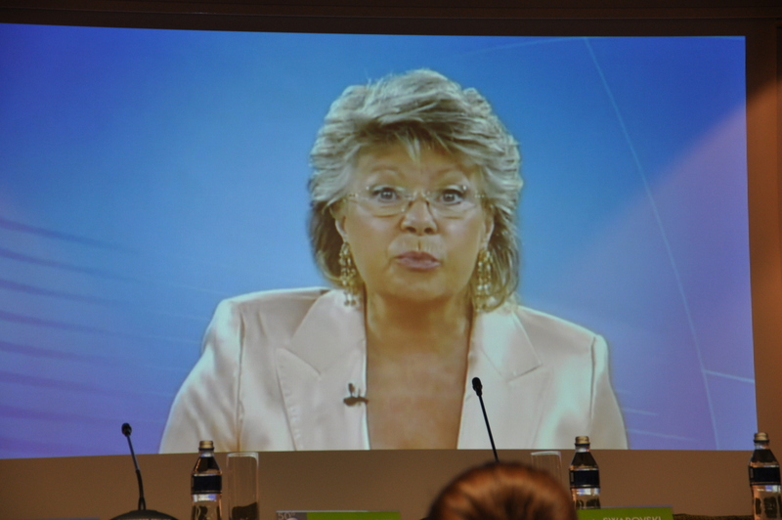
Video message by
Viviane Reding,
Vice-president of the
European Commission

A welcome address was delivered by the coordinator of the Bulgarian EJ Group and of the team that cooperated in organizing the congress Vassil Sotirov.
He expressed his hope that in finding the way out of the present crisis – the most serious one since the foundation of the EU, both its institutions and the member states will put the common interests of Europe and its citizens above the often contradicting national interests because this is the only way that the unique European project can go on.
Mr. Sotirov paid special attention to media freedom as a precondition for the shaping of a democratic and modern European society. It is unacceptable that more than 60 years since the start of the European unification process freedom of speech and media are in serious danger in a number of European countries, he said.
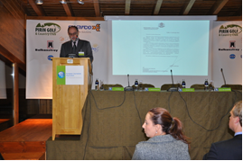

Welcome address by Vassil Sotirov, coordinator of the
Bulgarian EJ group.

Furthermore, media are economically dependent in many European countries and journalists are poorly paid and lack sufficient legal protection. All these problems are reflected in the quality of information and news analysis we receive every day. The European citizens are most disadvantaged by the media decline because they do not get sufficient and reliable information on some of the most important public and social issues.
After the European and Bulgarian anthems the congress was opened by the EJ president Paolo Magagnotti, who, before introducing the congress’ themes
gave the floor for special addresses to the guests of honors.
Two very critical topics were at the center of the presentations and discussion of the congress: “What Future for the European Union in a Highly Globalized and Interdependent World?” and “The Balkans and the European Union: Challenges and Perspectives”. Presentations and proposals regarding the Pirin and Rila Mountain Region and its Tourist and Economic Assets were also part of the program.

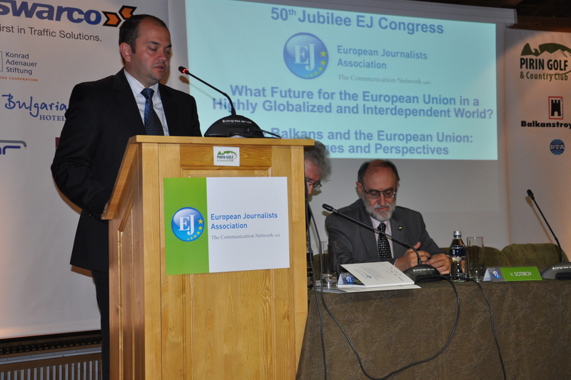
Address by Vladimir Zlatarsky, of the
Konrad Adenauer Foundation, Sofia

In his introduction the EJ President recalled the grave financial, economic and political crisis that we are facing today. While expressing great satisfaction with the achievements of the European unification since the end of WWII, he strongly regretted the fact the despite the pressing need of a stronger Europe to face the regional and global challenges, for many member states their national interests prevail over the establishing of an EU institutional architecture benefiting the entire European population. “It seems that when the political leaders sign the European treaties they don’t think of the consequences, thus ignoring rationality and far-sightedness to the detriment of all”, Magagnotti said. In this regard he referred as an example to the establishment of the Economic and Monetary Union without creating adequate European organs entitled to control the sovereign debts. He pointed also to the limited powers of the ECB as another obstacle to the successful governance of the Eurozone.
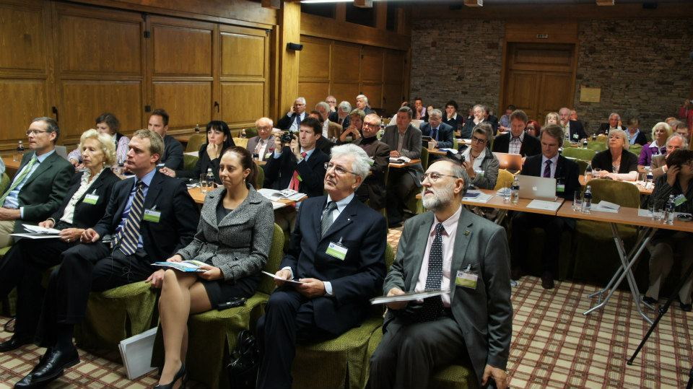

In regard to the still very critical situation in the Balkans the EJ President recalled the European reality described by the French Philosopher Jacques Maritain, who used to say that “high costs for small changes is a characteristic of Europe” and expressed his deep hope that all the actors involved will do everything to reduce such costs as much as possible.
Summing up his introductory remarks the EJ President underlined the necessity to make very clear which are the most important next steps which can guarantee the bright future of the European integration, and to advocate a sort of “refounding” of the European Union making it able to promote the well-being of its citizens in a spirit of solidarity and to contribute to the stability and peace worldwide.
In this context Magagnotti expressed concern on the threats to media freedom and to journalists in certain European countries and appealed to both the EU institutions and to the national governments to uphold the many declarations and conventions supporting the freedom of the press, first of all the “Charter of fundamental rights of the European Union”. In this regard the Congress unanimously approved a special declaration. (see www.european-journalists.eu).
In his introduction the EJ President paid tribute to the Association’s pioneers. For a special commemoration for those who were pioneering in both founding the Association and in promoting its activities in the first years and who are not anymore among us, the President gave the floor to the elder EJ member Zanel Fruchtmann.

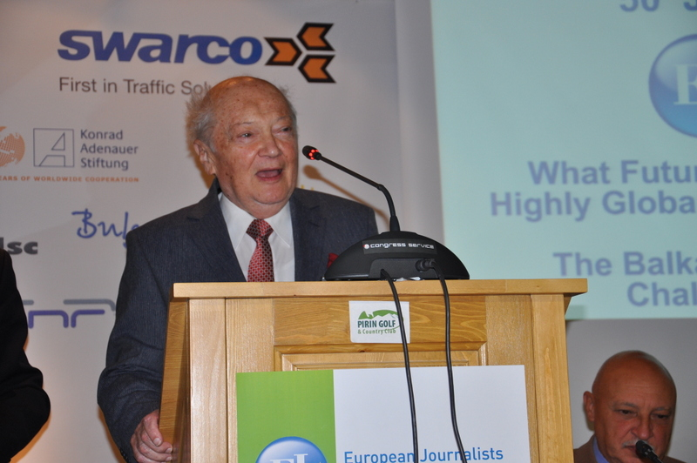
Zanel Fruchtmann

Egon Heinrich spoke with special word of remembrance for Marcello Palumbo, the last founding member who died recently and was considered the philosopher of the Association.
Main speaker on the first congress theme was Mr. Solomon Passy, President of the Atlantic Club of Bulgaria; frm. Foreign Minister of Bulgaria (2001-2005); frm. Chair of OSCE; frm Chair of the Security Council of the UN.

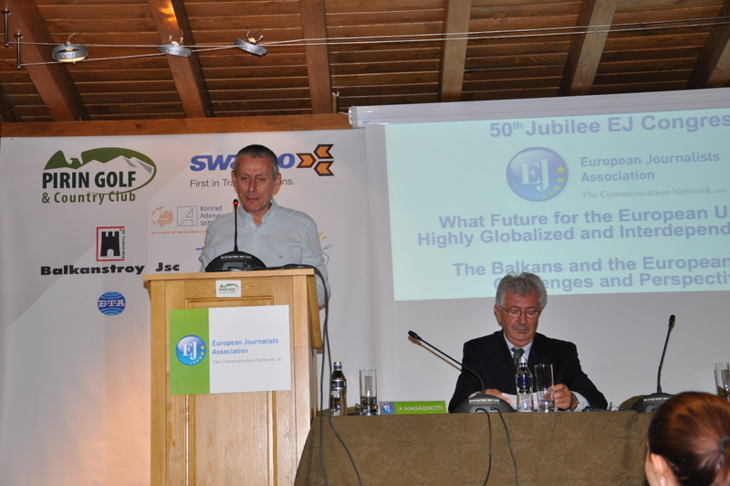
Solomon Passy makes his presentation as speaker on the EU future
session.

In his discourse on the future of the EU Passy made an overview of the difficult steps that led Bulgaria and other former communist countries out of the grip of the Soviet empire and brought them on a reform road towards NATO and the European Union. He was the first Bulgarian politician who proposed that Bulgarian should join NATO and the EU. Later, as Bulgarian foreign minister overseeing the negotiations for the accession of his country to the EU, he could rely on European solidarity but could also see the difficulties that are still affecting the relations between Eastern European member states and the entire EU system.
Passy underlined the need for more solidarity in Europe and for a more flexible institutional EU structure able to safeguard the national identity and at the same time to face the increasing global challenges. Europe should avoid egoism and give priority to the well-being of its citizens and to the international stability.
The Speaker welcomed the recent statement by European Commission President Barroso in favor of a European Union as a federation and expressed his hope that such proposals will soon be filled with concrete contents. Among the fields that he indicated for a stronger cooperation in a federal context were defense and foreign policy.
Passy put special emphasis on the urgent need to have a “common European energy policy”, a. o. because “energy will become more and more essence of international relations”.
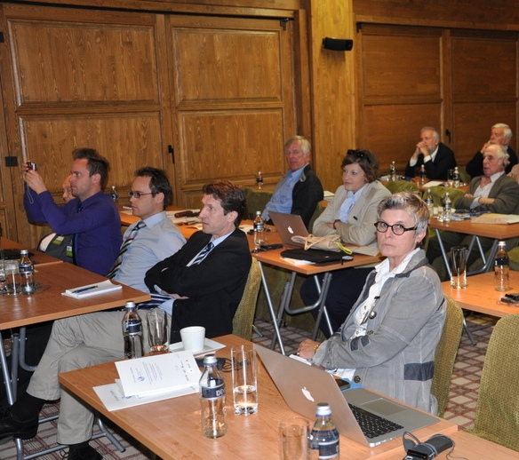

The first speaker’s presentation was followed by a panel chaired by Michael Jäger, CEO of the European Economic Senate, with five journalists and experts. Alexander Andreev, Head of the Bulgarian Service of the Deutsche Welle, saw the danger of a renationalization of the European politics. We should fight this tendency, he said, and it is very important that the media support this battle. For Rolf von Hohenhau, President of the Taxpayers Association of Europe, “with the financial crisis that we are facing today freedom in Europa has become more fragile” and the ESM doesn’t seem to be the right solution to solve the problem of public debts.
Helmut Hetzel, Benelux correspondent from the Hague for media in Germany, Austria, Switzerland and Luxembourg, who is also EJ Honorary President, expressed worries about the lack of a “real European public opinion” and concern about the lack of confidence of many young people in both the euro and the European Union. The reason for the lack of confidence is “a tremendous deficit of democracy in Europe”, Hetzel added. A better future for the EU would require empowering the EU institutions with more democratic legitimacy, he said.
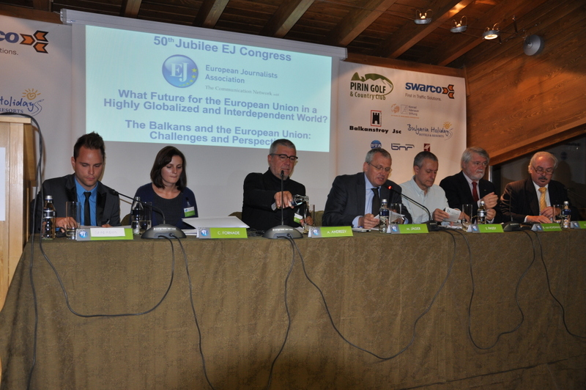

From left: Viktor Szabados, Corina Beatrice Fornade, Andrey Andreev,
Michael Jäger, Solomon Passy, Rolf von Hohenhau, Helmut Hetzel.

Corina Beatrice Fornade, coordinator of the survey “Hope Europe - Youth looking for new ways for their Future”, reported the result of an ad random survey regarding the attitude of young people of different countries towards the chances to find a job in their own country. “I'm asking myself how my future in Europe is going to look like and what I get as an answer is not very optimistic. I expect to be able to work in something adequate to my education but that is proving not easy at all. Besides, I feel that in my country there's no place and no opportunities for me anymore. And the same feeling has been gripping young people all over Europe now. So I'm even considering moving to other continents if needed”, was the opinion of a recent graduate from Portugal.
Very worried about the possibilities for young people to find jobs was also Viktor Szabados, president of the National Working Group of the Structured Dialogue with young People in Hungary. He also thinks that many young people are considering emigration too.

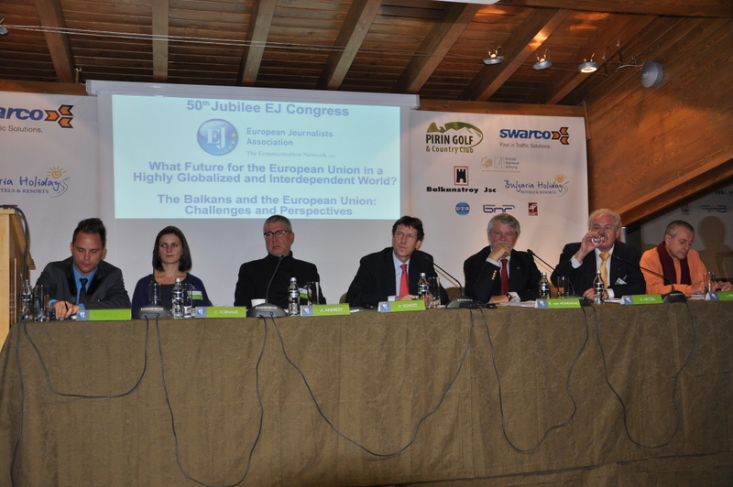
Hendrik Schott (center) moderates the debate on the future of Europe.

Both the panel and the following debate, moderated by Hendrik Schott, president of the EJ German section (VEJ), highlighted the need to strengthen the EU and to encourage member states to work for a new political and institutional structure of the European Union with more democratic legitimacy and efficient instruments to guarantee economic and social stability. These steps could restore the confidence of the European citizens in the EU institutions and in the future of the European project promoted more than 60 years ago by the courageous founding fathers. Regarding the role of the media in shaping the new EU it was pointed out that they can and must give an important contribution. Journalists should be more critical however towards both the EU institutions and the attitude of some member states.
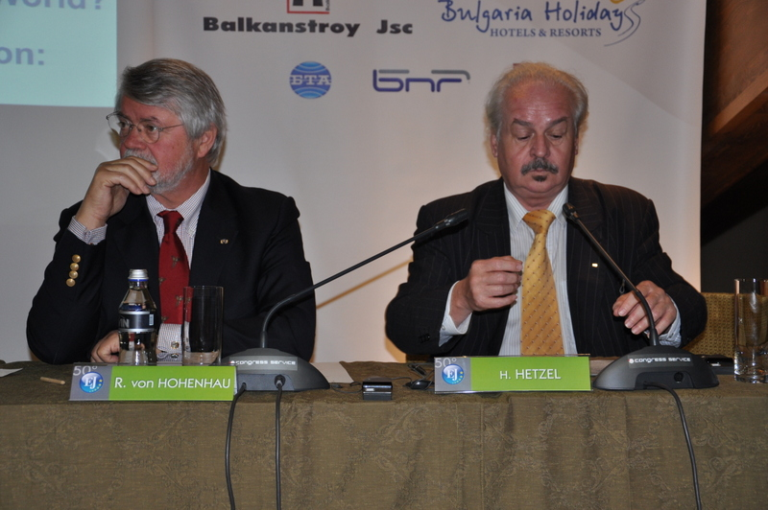

After the discussion on the future of the European Union the EJ Vice- president Rotger H. Kindermann made a detailed presentation on the 50 years of the Association’s story.

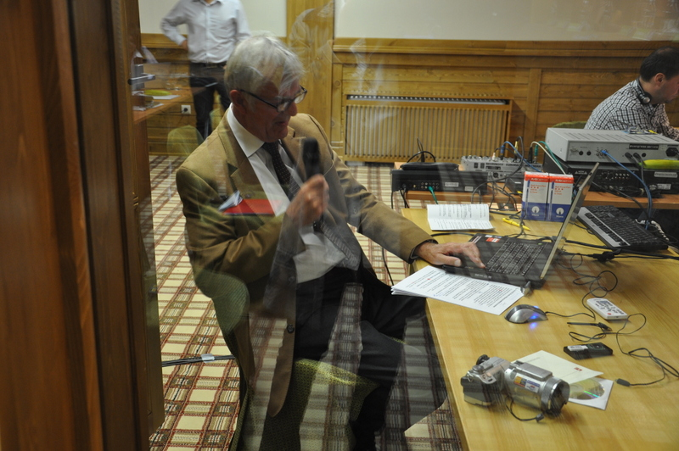

EJ Vice-president
Rotger H. Kindermann presents
the EJ story from the “back stage”.

It was moving to see the images of the beginning of the “mission” undertaken by the journalists of the six member states of the European Community just few years after the signing of the Treaties of Rome, and other highlights of the activities of the Association aimed at giving its contribution for the implementation of the European project.
Great interest among the participants and guests of the congress stirred the presentation of the BNT documentary by Boyko Vassilev “Before the Beginning” telling the unique history of a Bulgarian visionary who foresaw the birth of United Europe in 1926. In the afternoon of the first day of the congress the participants could learn many interesting aspects about local realities and features during a workshop on “The Pirin and Rila Mountain Region and its Tourist and Economic Assets” moderated by the Bulgarian EJ members Lyudmila Videnova and Evelina Vatova.
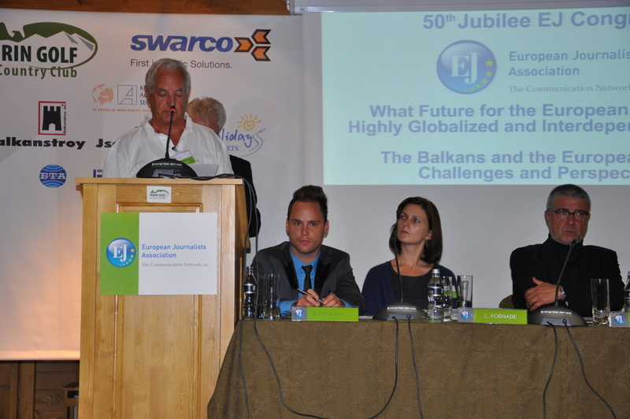

Enzo Farinella
presents
a Congress’ declaration.

The mayors of Bansko - Georgi Ikonomov, and of Razlog - Krasimir Gerchev, with the support of municipalities’ staff, presented an overview of their region.
Afterwards Alexander Swarovski, vice-president of SWARCO, spoke about the role of infrastructures in touristic regions. Jaques Campé, secretary-general of FIJET, analyzed the main elements attracting tourists to a region.
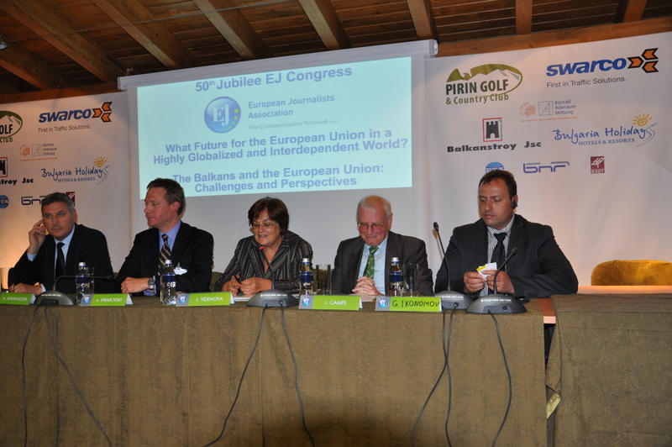

From left:
Georgi Ilkonomov, Alexander warovski, Lyudmila Vidonova,
Jacques Campé,
Krasimir Gerchev.
The conclusion was that the Pirin and Rila mountain region has a significant potential for touristic development. Projects like Pirin Golf & Cuntry Club are for sure attractive structures, even, as Swarovski said, modern and safety infrastructures like roads are essential also for the touristic development.

Of utmost interest has been the discussion on the second day of the congress on “The Balkans and the European Union: Challenges and Perspectives”. The Bulgarian EJ coordinator Vassil Sotirov introduced the theme and the speakers and subsequently chaired the panel and moderated the debate.
The two main speaker were Andrey Kovatchev, Bulgarian MEP, member of the bureau of the Group of the European People's Party, vice-chair of the Committee on Foreign Affairs in the EP; and Stanimir Ilchev, Bulgarian MEP, member of the Group of the Alliance of Liberals and Democrats for Europe, member of the EP delegation for Albania, Bosnia and Herzegovina, Serbia, Montenegro and Kosovo.
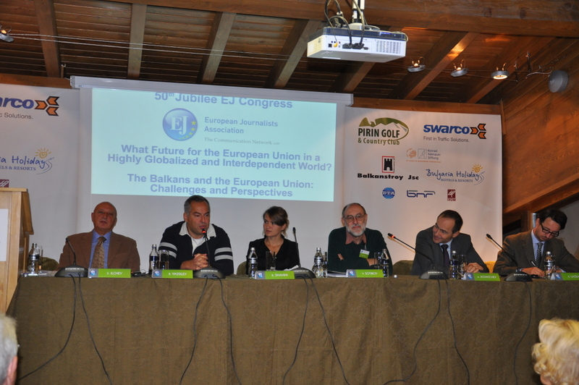

From left: Stanimir Ilchev, Boyko Vassilev, Besa Shahini, Vassil Sotirov, Andrey Kovatchev, Dan Lazea.

From left: Stanimir Ilchev, Boyko Vassilev, Besa Shahini, Andrey Kovatchev,
Dan Lazea.

Andrey Kovatchev pointed out three main aspects and commitments related to the area of the Balkans: The European Union has a commitment for membership towards the Western Balkans: when these Balkan countries will be ready, they must become EU members. The Eastern partnerships will be offered association status for the foreseeable future. We need stability in the South of the Balkans.
Stanimir Ilchev began his presentation underlying the attitude of some countries of the area towards their place in the Balkan region. Albania, for example became involved in the area just in the last decades, and Romania doesn’t even consider itself part of the Balkans. Talking about the Balkans we need to consider in a special way the deep differences within the region - differences in terms of language, religion and minority groups for example; in addition to that, we need to take into consideration the Roma question with local internal diversities. Ilchev expressed further specific worries about the attitude of Macedonia towards the neighboring countries Greece and Bulgaria. He paid attention to the failure of Skopje to cooperate on the occasion of special anniversaries or events. Even the question about name of Macedonia is a critical one.
The panel began with an intriguing discourse by Boyko Vassilev, anchorman and political commentator of the Bulgarian National Television. “As a journalists who has been covering the Balkans for a long time I see a very disturbing situation right now”, Vassilev said, and added ”If we look at the Western Balkans we see that Croatia is joining (the EU) and we see that the only other country that has the prospect is the smallest one - Montenegro”. The Bulgarian journalist doesn’t see membership chances for any other Balkan country because the EU right now is not in a position to offer anything in order to play its old “stick and carrot” game which allowed Bulgaria to join the EU.
He further expressed his worries that the Balkans are not anymore “media sexy”.
Dan Lazea talked about the Balkans “geography a as most imaginary thing”. He recalled a statement by a Moldavian scholar on the occasion of a meeting in Timisoara about the EU enlargement before Romania joined the EU who said that “from a pure geographical point of view Moldova is in the very center of Europe”, while “from our point of view Moldova is actually part of the Eastern partnership”. The reality is that talking about the Balkans requires different languages when speaking to different audiences.
Lazea recalled the problematic attitude of Romania towards Serbia’s aspiration to become EU member, thus highlighting the political complexity still existing in regard to the relations between the Balkans and the European Union.

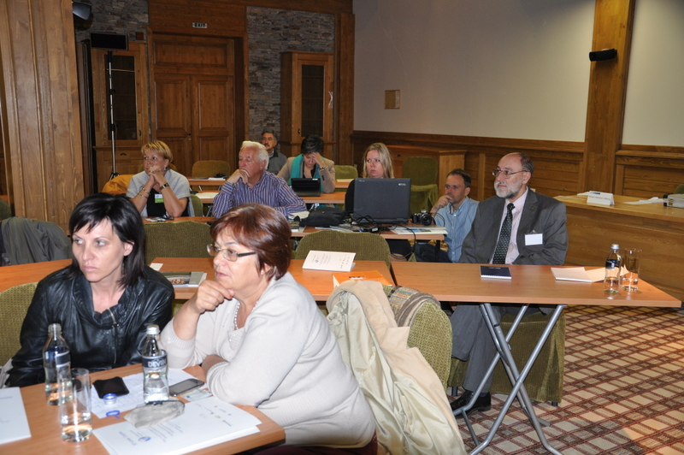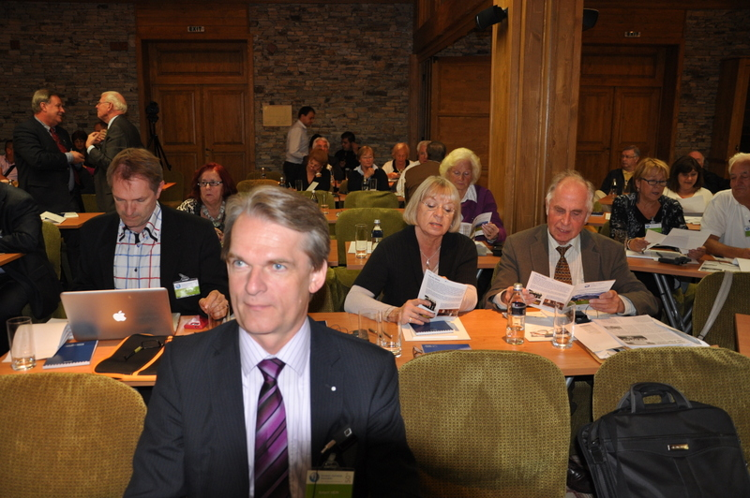

The panel ended with a presentation by Besa Shahini, senior analyst of the European Stability Initiative in Pristina. This year she attended many events discussing the EU enlargement and came to the conclusion that there is no possibility for any enlargement in the near future because consolidation of the existing situation is top priority. Nevertheless the Western Balkan countries have done a lot in recent years to achieve progress and to solve issues prescribed by the European Union. This made possible for all in former Yugoslavia to travel without visa. We have now two official candidates for EU membership - Macedonia and Serbia; Albania has not yet received an opinion for candidacy. Montenegro is working hard to achieve it. Bosnia and Herzegovina hasn’t even applied yet.
“Enlargement however is not over”, Shahini said. She welcomed extra requirements for accession, which will allow better preparation on administrative level and on other aspects.
Both the presentations of speakers and panelists and the subsequent debate highlighted the still complicated, difficult and serious situation in the Balkans with regard to the EU, but there were no doubts that all the parties and actors involved must do everything to create the conditions to take the Balkans into the European Union.
After the concluding words of the EJ President Paolo Magagnotti the participants spent the afternoon visiting the amazing Rila monastery. Everyone enormously enjoyed the performance of original Bulgarian, Macedonian, Serbian and Greek music on the closing farewell dinner in the Country club of the Pirin golf resort.
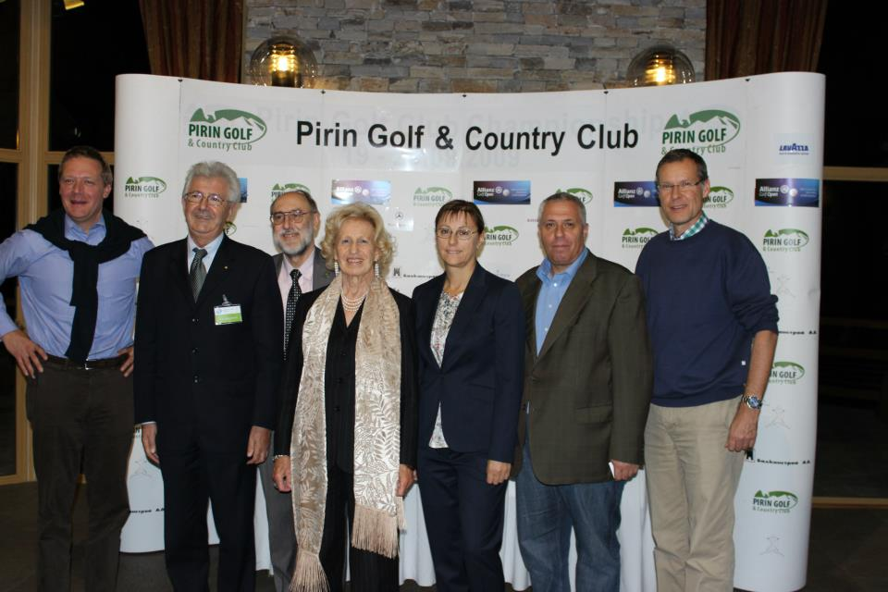

From left: Alexander Swarovski, Paolo Magagnotti, Vassil Sotirov, Maria Romana De Gasperi, Katya Kanazireva and Yordan Kanazirev (owners of “Pirin Golf & Country Club”), Sven-Georg Adenauer.

