50th Jubilee Congress of EJ On Track

The EJ president Paolo Magagnotti together with the Bulgarian ExCom member Vassil Sotirov visited in early August the Pirin Golf and Country Club in the South–west of Bulgaria – the venue of the 50th EJ Jubilee Congress to be held on Sept. 20-23.

The met with the owner of the beautiful tourist complex Mr. Yordan Kanazirev, a strategic partner of the Congress, and with the club stuff to discuss the preparation of the event that will gather journalists coming from many EU and non-EU countries.

The Congress will be devoted to discussions on two main themes:
1. What Future for the European Union in a Highly Globalized and Interdependent World?
2. The Balkans and the European Union: Challenges and Opportunities.

It was concluded that he preparation of the Congress is going on smoothly and a successful and meaningful outcome is expected. Participating journalists and experts will express their deepest concerns that the present crisis in Europe threatens the very future of our continent. They will give their contribution to promote a positive development worthy of the spirit and the courageous and far-sighted project of EU’s founding fathers.

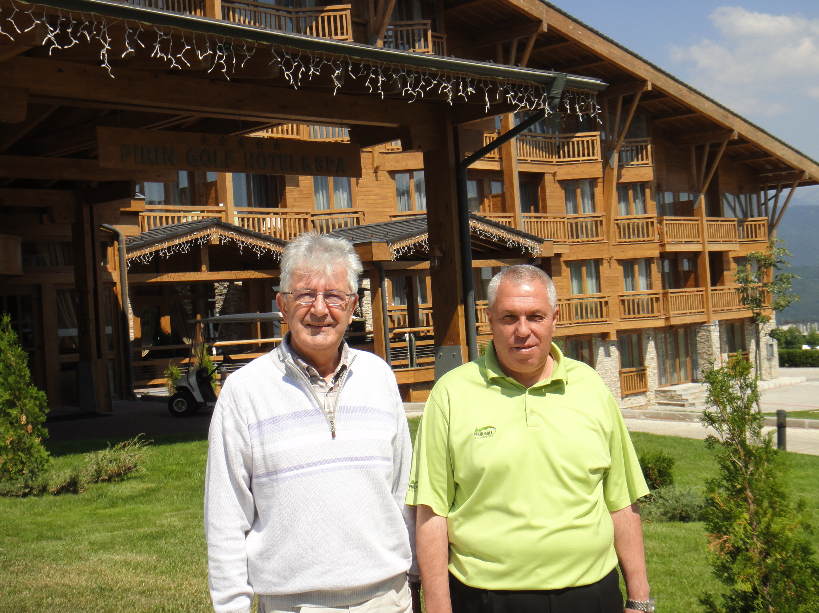
EJ President Paolo Magagnotti with Mr Yordan Kanazirev
in front of the Pirin Golf &Spa Hotel where the Congress will take place.

