50th Jubilee Congress of EJ in Bulgaria Opens September 21, 2012

The 50th Jubilee Congress of EJ will gather more than a hundred delegates and guests from the whole of Europe in a beautiful venue in Bulgaria – The Pirin Golf and Country Club , from September 20 to 23, 2012. Guests of honour will be Maria Romana de Gasperi - daughter of Alcide De Gasperi, one of the founding fathers of the European Union; Sven-Georg Adenauer - grandson of Konrad Adenauer, another of the founding fathers and Alexander Swarovski, Swarovski Crystal and Vice-president of SWARCO.
The decision to hold the Jubilee congress in Bulgaria was taken in May last year in Timisoara, Romania, on the occasion of the 49th EJ Congress.
Two topics will dominate the discussions: “What Future for the European Union in a Highly Globalized and Interdependent World”, and “The Balkans and the EU – Challenges and Perspectives”.
Main speaker on the first topic will be Mr. Solomon Passy - president of the Atlantic Club of Bulgaria; frm. foreign minister of Bulgaria (2001-2005); frm. Chair of OSCE, frm. Chair of the Security Council of the UN. Main speakers on the second topic will be Bulgarian MEPs Andrey Kovachev and Stanimir Ilchev. The congress will be opened by the President of EJ Paolo Magagnotti. Welcome messages are expected from the President of the European Parliament Martin Schulz and the Vice-president of the European Commission Viviane Reding, as well as from other Bulgarian and European politicians.
The holding of the congress in one of the most perspective tourist destinations in the Balkans and Europe stimulated the interest of FIJET – The International Federation of Journalists writing about Tourism, whose General Secretary Jacque Campe will participate together with Antonio Bonelli – tourist media publisher in Italy and President of FIJET.
The Bulgarian organizers headed by Vassil Sotirov – journalist from the “24 Hours” daily and Excom member of EJ, working jointly with the EJ President Paolo Magagnotti, have made sure that the congress will be held in a friendly atmosphere and a beautiful venue. The congress is supported by the European Commission, The Konrad Adenauer foundation, as well as by corporate sponsors: Pirin Golf and Country Club (Bulgaria), Bulgaria Holidays, Balkanstroy (Bulgaria), Swarco (Austria). Media partners of the event are the Bulgarian National Television, the Bulgarian National Radio and the Bulgarian National News Agency.
In the context of the Congress the EJ annual General Assembly will take place; it will vote among other two motions, one on the Future of the European Union and the second one on the media freedom.

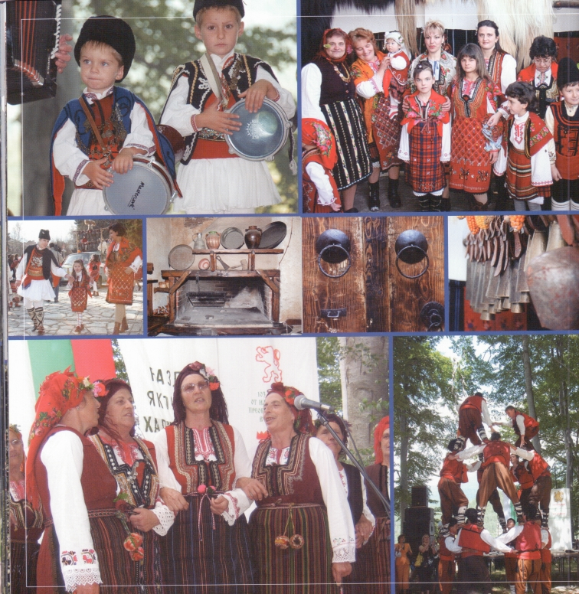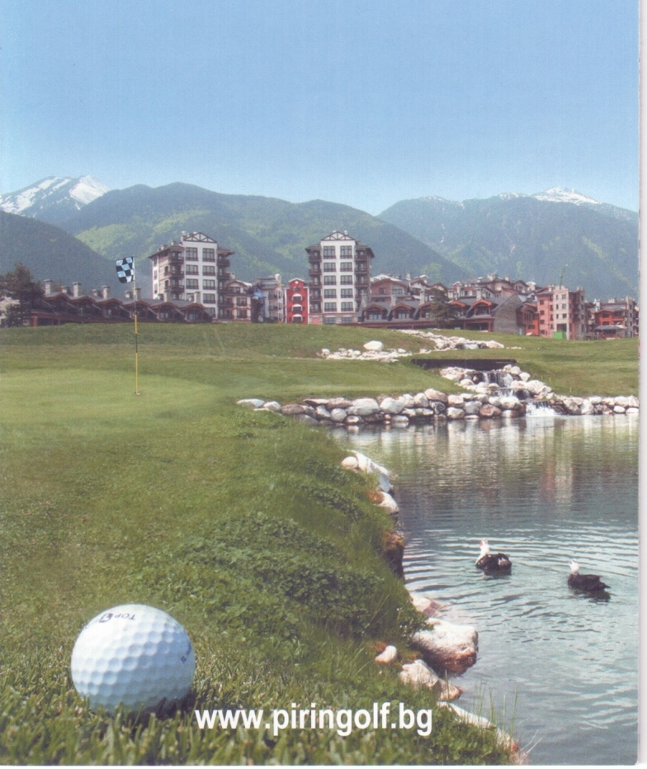

Cultural Features, Sporting and
Culinary Surprises for the Congress in Bulgaria

The 50th Jubilee congress of EJ from September 20 to 23, 2012 will take place in Bulgaria. It will gather delegates and special guests in one of the most beautiful tourist spots in the country and in the Balkans – The Pirin Golf and Country Club. The unique complex is situated in a high valley where the three highest and most beautiful Bulgarian mountains converge – the alpine-type Pirin and Rila with the mildly shaped Podopi.
The Pirin Golf and Country Club was created recently upon a unique plan as a tourist village with all the facilities for the popular green sport but also with perfect conditions for SPA vacationing. A new 5-star hotel all made of stone and wood was recently opened. It will be the venue of the EJ congress. The complex is located in the foothills of the Pirin mountain which is one of the most attractive new European ski destinations in the last decade. It has some of the longest and most beautiful ski slopes often praised by the most famous world skiers, among them Alberto Tomba. He gave his name to one of the slopes on which several world cup tournaments have taken place.
The picturesque vicinity also offers a variety of options for summer and cultural tourism. Not far from here, in the heart of the Rila, considered to be sacred mountain, tens of thousands people come yearly to visit and pray in the Rila monastery – a unique cultural and architectural monument, one of the historical symbols of the Bulgarian nation, nestling priceless treasures from several ages. The congress participants will have the opportunity to visit it.
They will also have the chance to see the alpine ski centre over Bansko and to have short walks in the two neighboring towns in the valley – Bansko and Razlog, harbouring the typical atmosphere and architectural style of this part of Bulgaria.
The hosts and the Bulgarian organizers have prepared a special evening surprise – a “dinner in the woods” with authentic folklore from Bulgaria, Macedonia and Serbia performed by famous Balkan musicians.

